Independent Study Report on Cooperative Robotics
By Shane Avery
August 2006

Table of Contents:
Introduction 2
Governing Algorithms (Rules) 3
Environment 6
EarthSat 7
MarsSat 12
Mars 15
Robots 15
Balls 15
Task Description 17
Task Definition 17
Environmental Challenges and Restrictions 17
Implementation Steps 18
Messages 20
Test Cases 22
System Progress to Date 24
Work Remaining 24
Conclusion 25

Introduction
In the past ten years there has been an increase in the number of probes sent to explore the solar system. Mars has been the target of many of these probes in the form of robots sent to learn about the planet. Sadly, a significant percentage has been unsuccessful reaching the Martin surface.
One possible solution would be to send multiple cheap robots to the Martin surface, possibly spread out some time apart to fix possible problems learned from similar robots which never landed. The key to keeping cost down would be to supply only some of the needed equipment to the robots for completion of the task. Thus, when the robots land on the surface they will need to cooperate and work together to complete the mission. This project will focus on the robots after they have landed and now need to complete a task irregardless of what robots are dead or damaged. This will be done by first developing algorithms that govern the behaviors of the robots. Then a physical implementation of a system will be developed to prove the worth and validity of such algorithms.

Governing Algorithms (Rules)
The first step of the project is to develop algorithms which will govern the actions of the robots and support devices. Here we have laid such algorithms as “rules” which the robots and support devices must adhere to. These “rules” are meant to be generic in nature and while they will apply directly to this implementation they are not exclusive to it. The purpose of developing the algorithms is so that they may be applied to any similar scenario. The “rules” apply to the following configuration:
- Robots are capable of communicating with other robots directly.
- Robots are capable of communicating with a Martian communications satellite.
- The Martian satellite communicates with robots.
- The Martian satellite communicates with an Earth communications satellite.
- The Earth satellite communicates with the Martian satellite.

There is one important distinction that needs to be made about this configuration. Only robots are allowed to take damage. The Martian communication satellite and the Earth communication satellite are assumed to be always functionally healthy. The reason for this is that the people of Earth have had fair success in getting satellites to orbit both Earth and Mars. So, when we state in the configuration that a robot is capable of communication that means that it left Earth with the intention that it would be able to communicate but it may arrive at Mars unable to do so.
With this in mind here are the list of rules that govern the actions of robot and communications satellites with short descriptions and examples for clarity:
- A robot may send data to another robot - An example is the robot responsible for finding the balls may tell the robot that reads the IR data where the balls are located. This is the most efficient way for the robots to share data.
- A robot may send data to the Martian Satellite - An example is the robot responsible for finding the balls may tell the Martian satellite where the balls are located. This way the Martian satellite can relay the information to the Earth satellite as well as other robots. This is important because if one robot cannot communicate directly with another robot, but can communicate with the Martian satellite, then the data of interest to be shared among the robots can be relayed via the Martian satellite.
- Martian satellite may send data to a robot - If a command needs to be sent from Earth to the robots then this is the only way it can be accomplished. Also, if data needs to be relayed from one robot to another (in the case that direct communication between robots is not possible) then the Martian satellite needs to be able to relay data between the two robots. Additionally, the Martian satellite will have some intelligence and thus given some information from the robots it can give the robots commands.
- Martian satellite may send data to the Earth satellite – Robot status and environment data are sent to the Earth satellite for display and information gathering via the Martian satellite. If the robot becomes confused or runs into a problem that it cannot solve, it may need help from the people on Earth. The only way to relate the need for help and the problem is to send the data to the Earth satellite via the Martian satellite.
- A robot can’t tell another robot what to do - Robots will never autonomously command robots. Only the Martian satellite or the Earth satellite (via the Martian satellite) may command a robot. It should be noted however, that a robot may relay a command Martian satellite or the Earth satellite to another robot. This is to avoid the confusion of two or more robots at a time giving commands to one robot.
- A robot must have some autonomy - It would be impractical for the people of Earth to control every movement of the robots due to the long latency of communications from Earth to Mars. Thus, the robots must be able to accomplish most things autonomously.
- A robot must not be completely autonomous - When robots become confused or reach an obstacle they can't overcome the robot should stop and ask for help. Examples are that the robot expects to see a ball but it isn't there or there is a giant canyon between where it is and where it wants to go.
- Anything the robot is currently doing can be overridden by commands from the Martian satellite or the Earth satellite. If a robot is in an autonomous task then it must be able to resume that task on its own - Whether the robot is doing nothing or in the middle of a task, if it is commanded to do something it must immediately obey. If the robot was in an autonomous and was commanded by the Martian satellite or the Earth satellite and then told to resume, the robot should go back to completing it autonomous task automatically. Note that if the robot is in an autonomous task, given command A then before the robot completes command A is given command B, and then told to resume, the robot will not resume command A. It will resume its autonomous task. The only task the robot will ever resume is the autonomous task. Any interrupted non-autonomous task will never be resumed and can be thought of as permanently forgotten by the robot.
- Once commanded the robot will attempt to execute the command until confused, given another command, or until complete even if the robot has intermittent errors - In the event that the robot has intermittent errors he should continue to execute the command. Examples are communication temporarily goes away (satellite becomes obstructed for example), or there are power problems (robot maybe powered by solar energy and it maybe night), mechanical failures, etc. If these occur the robot should report the problem, if possible, but continue to execute nonetheless.
- Damage information should be shared - Robots should share their damage information with each other. This will affect how robots make their autonomous decisions. An example of this is that if two robots are assigned to find water in two different locations and one robot is unable to complete the task due to damage, the healthy robot will autonomously decide to go to both locations to find water. This is also critical for relaying message. An example of that is if one robot can’t communicate with the Martian satellite another robot may automatically relay messages to the Martian satellite for the damaged robot.
- All environmental data should be shared - Robots should share any environmental data to aid in autonomous decisions. An example would be that the robot finding balls will report the location of the balls to all robots. This way the robot that reads IR data knows where to go to find the balls. Another example would be a robot that finds rocks that contain information about life on Mars would share the location of that rock to all robots so that the robot that analyzes the chemistry of that rock will know where to find it.

Environment
For our implementation the environment consists of robots, balls (racquet balls), Mars, a Martian satellite, Earth, and an Earth satellite. We will call the Earth satellite EarthSat and the Martian satellite MarsSat. Below is a visual representation of the system as a whole.
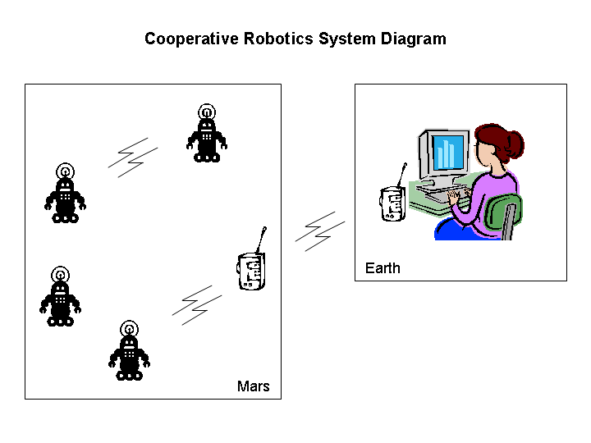
Earth will comprise of the EarthSat device and a PC. The EarthSat device is a custom PCB which communicates with the PC. Mars is comprised of a MarsSat device, which is similar to the EarthSat device and a white wooden board with black electrical tape that the robots and balls will live on. The subheadings below will give a more detailed description of each of these environmental entities.

EarthSat
The purpose of the EarthSat device is to get data from the MarsSat device and send it to Earth for display or processing of data and to relay commands from Earth to the robots. Thus, the EarthSat device will wirelessly communicate only with the MarsSat device and will communicate serially only with the PC.
The EarthSat device is comprised of two major components. The first is the physical PCB where the wireless module (in this case ZigBee) is located and the second is the software that runs on the PC computer which controls the ZigBee module.
The PCB is quite simple and contains the ZigBee module made by MaxStream (www.maxstream.net) called XBee, a RS232 transceiver to level shift the serial port signals to the proper voltages, and a voltage regulator to regulate our 9V input to the operational voltage of the PCB (3.3V). The PCB was made with a ProtoMat machine which make prototype PCB by cutting holes and traces in copper boards. The parts themselves were bought from DigiKey (www.digikey.com) and soldered to the PCB. The PCB was designed to be powered by a 9V DC power supply that is plugged into the wall. The schematic and board layout was done with a program called Eagle (www.cadsoftusa.com).
The XBee module powers up at 9600 Baud with hardware flow control. Also, it powers up in Transparent Mode which is not useful for us. We use the PC software to change the mode to API Mode which will allow us to easily communicate with different XBee modules.
Of particular note is that the PCB has two XBee modules. The second XBee module is only used for testing and not part of the normal operation of the device. The second XBee module is used to emulate the behavior of the robots. In this manner the communications between the MarsSat device and the robots can be tested without actually developing a robot. To do this we use the PC and write software that can emulate the behavior of the robots to test the functionality of the MarsSat device.
Below is a picture of the schematic, board layout, and finished product.
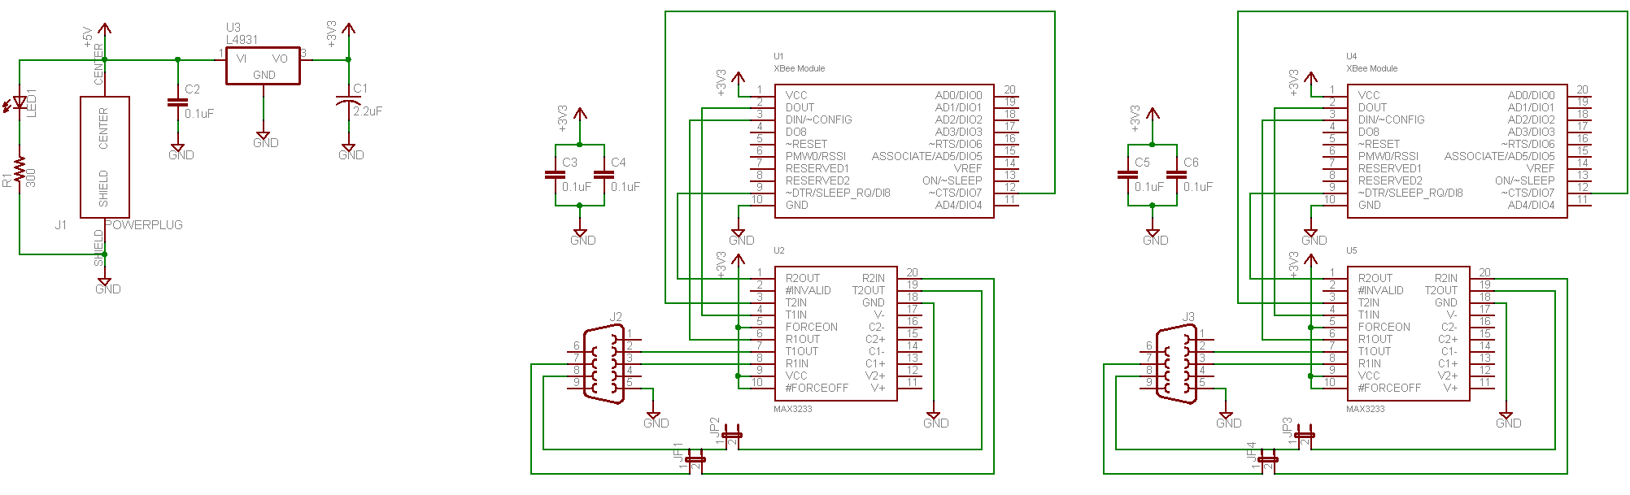
Schematic

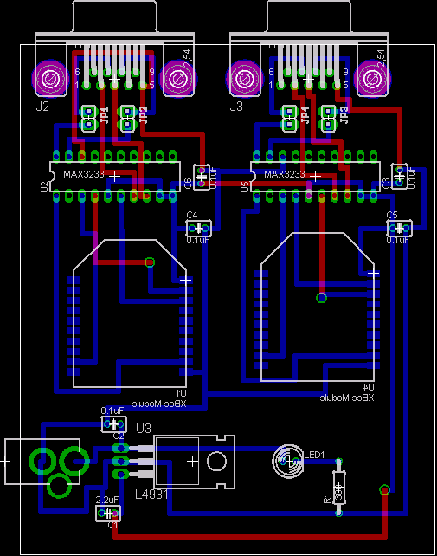
Board Layout

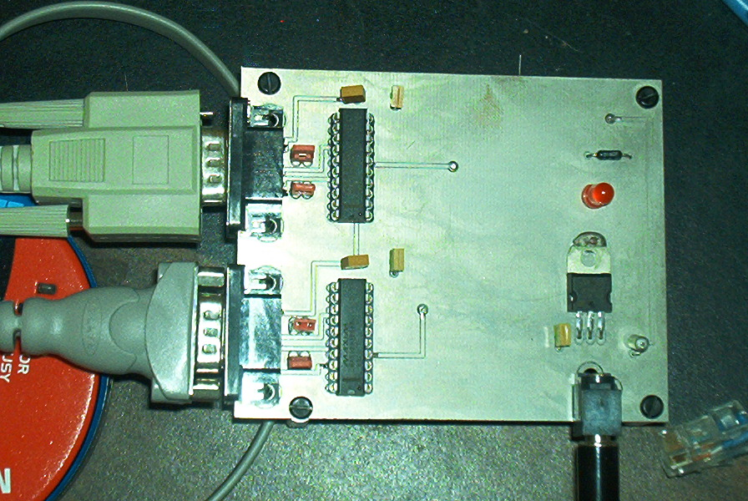
EarthSat PCB Top View

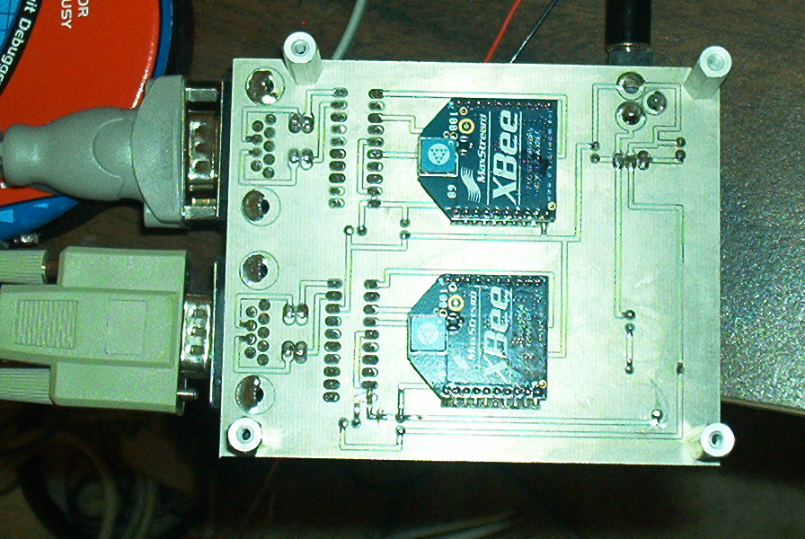
EarthSat PCB Bottom View
The other crucial thing that makes up the EarthSat entity is the software written for the PC that will control the PCB. The software was written using Borland Builder 6. It will not only interface with the EarthSat PCB (by communicating with the XBee module and configuring it) but it will log all messages to a file, display the status of the robots, display the status of the ball, and display the location of the robots. It will also have buttons that will tell the EarthSat PCB to send commands to the MarsSat device.
In addition, the PC software has many ways to examine and review messages for all entities in the environment. For example, it will allow us to playback the log file to view the message that were sent and received by the EarthSat device. Each robot and the MarsSat device contain an EEPROM which will log all of their messages and the PC software provides a way to dump that EEPROM data, display the contents of that data in a separate window, and store the data in a file.
Thus, this PC software would be analogous to what the people of Earth would use to monitor and control robots on Mars as well as gather information about their environment. Below is a screenshot of the PC software.
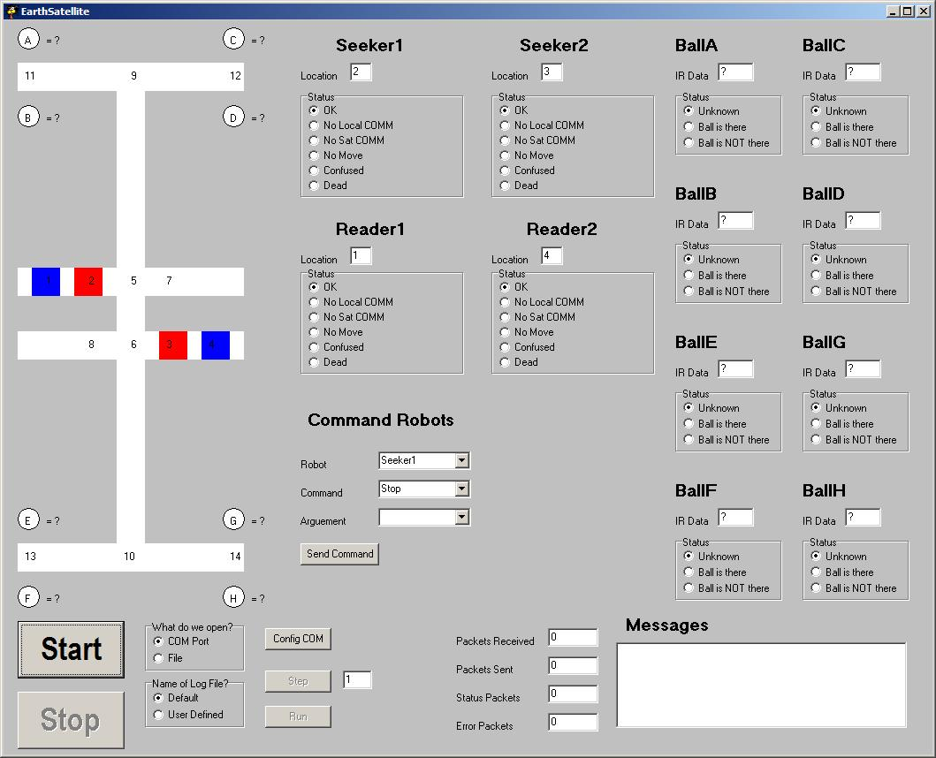

MarsSat
The purpose of the MarsSat device is to relay information between robots, give robots commands, relay messages/information from the robots to EarthSat, and relay commands from EarthSat to the robots.
The MarsSat device is similar to the EarthSat device in that it contains an XBee module for wireless communication. However, instead of attaching it to a PC, the XBee module will serially communicate with a PIC16F877A micro-controller from Microchip (www.microchip.com). The code for the PIC16F877A is written in C and compiled the CCS compiler (www.ccsinfo.com) which is integrated into Microchip’s IDE called MPLAB. The MarsSat device will be powered by a 9V battery and a voltage regulator will provide the voltage of the MarsSat PCB (3.3V).
Just as with the EarthSat PCB the MarsSat PCB was constructed using a PCB prototyping machine called a ProtoMat. The parts include the XBee module, the PIC controller, a voltage regulator, and a battery holder (9V battery). All parts were purchased through DigiKey.
Like the PC software the PIC controller must communicate with the XBee module serially at 9600 Baud with hardware flow control. The PIC controller must configure the XBee module to be in API Mode and handle all intelligence associated with the incoming and outgoing of messages. In addition the PIC controller must store in EEPROM any message it sends or receives so that EarthSat may recall it at any time for analysis and/or viewing.
Below are pictures of the MarsSat schematic, board layout, and PCB.
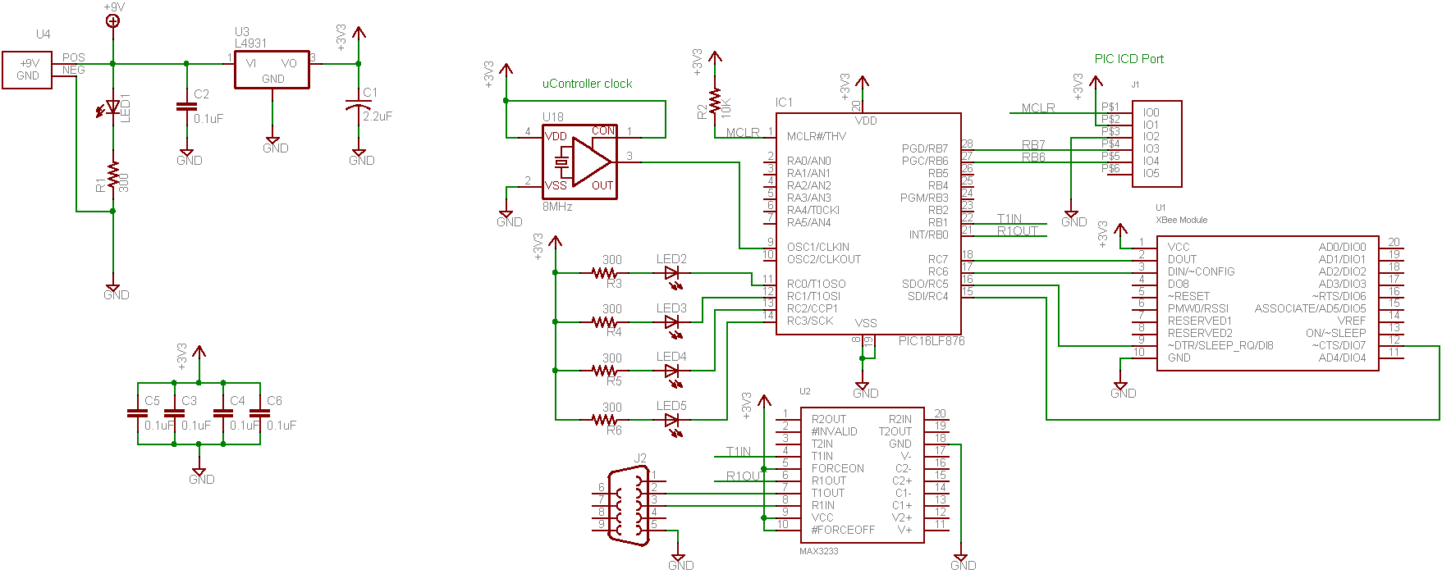
MarsSat Schematic

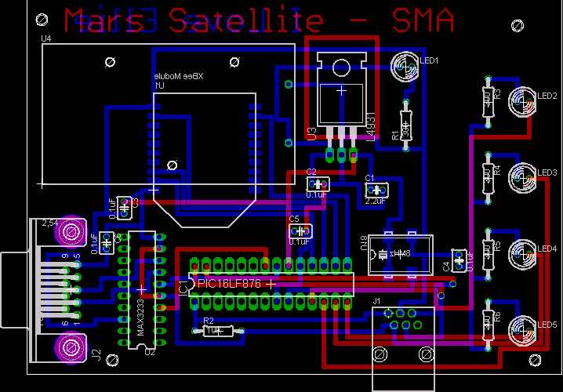
MarsSat Board Layout
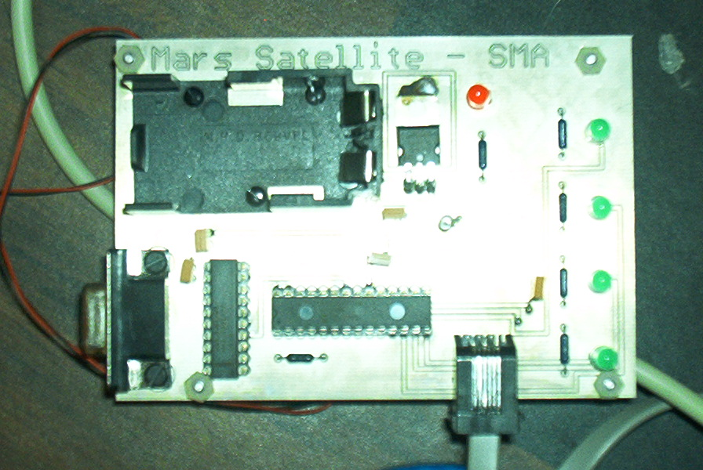
MarsSat PCB Top View

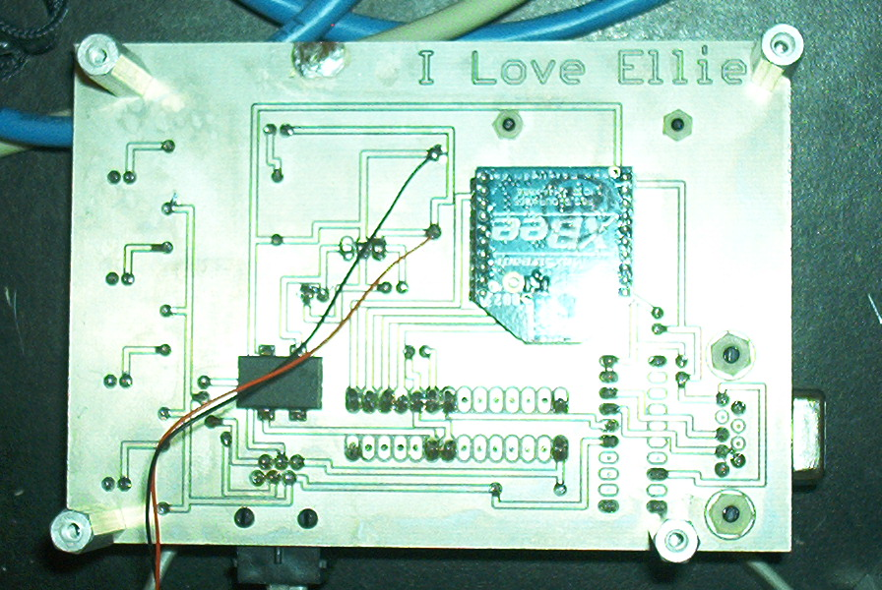
MarsSat PCB Bottom View

Mars
The purpose of Mars is that it provides a place for the robots to complete a task. Mars will be made of a white glossy finish thin wood board. This board will have black electrical tape on it that the robot will use to follow. In addition the board will have small holes or dimples cut in it in eight locations. These eight locations will be where the ball will reside.

Robots
There will be two kinds of robots called Seekers and Readers. Before we instill damage on the robots there will be two Seekers and two Readers. Each robot will have two virtual communication devices (in reality they only have one as I am not made of money and those XBee modules cost too much). The first communication device is a local communication device that is meant to communicate between other robots. The other communication device is a long range communication device that will communicate with the MarsSat device.
The purpose of the Seeker robot is to find where the balls are located and the purpose of the Reader robot is to read the IR data emitting from the balls. The robots will have one XBee module (even though they have one, software will model as though the robot has two) and use the PIC controller as the MarsSat device (PIC16F877A). Robots will store all incoming and outgoing messages in EERPOM so that Earth may recall it at anytime for analysis/display.
The robots will be powered by a rechargeable lithium polymer battery with a voltage regulator to provide the system voltage (3.3V). Parts will be the same as the MarsSat device and all they will be bought through DigiKey. The robot chassis, motors, sensors, wheels, etc. will be bought from an online hobby robots store that is TBD.

Balls
There will be four balls placed in the environment and each ball will emit a number via an IR transmitter that is unique to that ball. The balls will be racquet balls and will have washers glued to the bottom to keep them from rolling away. In addition, a hole will be cut in the ball to insert the electronics to emit a constant IR signal. Another separate hole which will face the robots will be where the IR emitter is placed. The controller, IR emitter, etc. will be bought at an online store that is TBD.

Below is a picture of the Mars environment with the possible ball locations, starting and ending positions of the robots, and where the electrical tape will be placed.
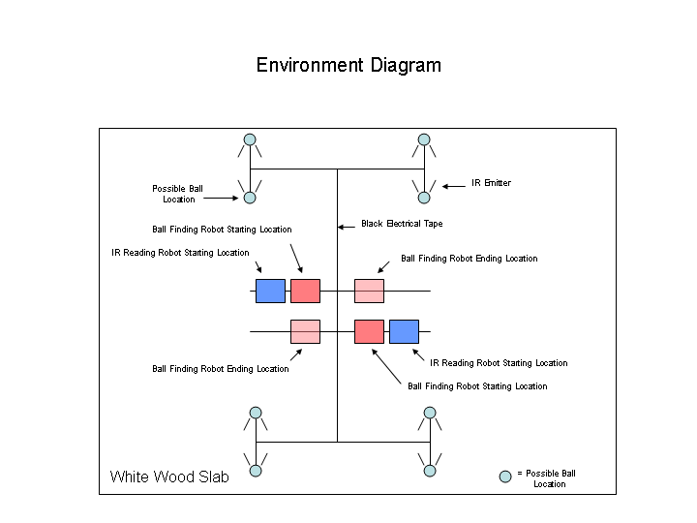

Task Description
This section will describe in detail the task the robots must complete.

Task Definition
The task is actually quite simple. Before the task is to begin four balls will be randomly placed somewhere in the eight possible locations. Thus, of the eight possible ball locations, four spaces will be empty and four will contain balls. The Seeker robots will then travel to all the possible ball locations to determine if there is or is not a ball there. Once it is determined where the four balls are located the Reader robot will travel to the ball locations and read the IR data emitting from the balls.
The challenge however is not in completing the task. Before the robots can begin their task a randomizer will select which robots will incur what damage. Then robots expected to complete their task irregardless of the fact that they may be damaged. We will not however damage the robots so completely that they will be unable to complete the task. Thus, there are restrictions as to what combinations of damage the robot may incur. This is explained in further detail in the next subheading.

Environmental Challenges and Restrictions
Here is a list of the possible types of damage the robots may incur along with the restrictions.
- Death – A robot maybe killed. If a robot is considered dead it can no longer be communicated with either by another robot or by the MarsSat device. Therefore it cannot relay data or be given commands. The restriction to this is that at least one robot of each kind must remain alive and be able to move. Thus, we can’t kill the first seeker and then kill or cripple the second seeker as then we would have no means of finding balls.
- Movement – A robot maybe crippled. This means that a robot can’t move. The robot can however communicate. Thus, a crippled robot can still share data and relay message and therefore is not useless. The restriction to this is the same as Death.
- Local Communication Failure - If this happens then a robot will be unable to communicate directly with other robots. However, a robot may still communicate indirectly with other robots by relaying messages via the MarsSat device. The restriction to this is that a robot may loose local communications but it cannot loose both local communications and satellite communications. If this were to happen then the robot would be considered dead. There is an additional restriction that at least one robot must have both local and satellite communications.
- Satellite Communication Failure – If this happens then a robot will be unable to communicate directly with the MarsSat device. The robot may still be able to communicate indirectly with the MarsSat device by the relay of messages or data from another robot. The restriction here is the same as with the local communication failure.
- Confusion – There is only one condition where a robot will stop and become confused and it will only happen to a Reader robot when he expects to see the IR data from a ball but doesn’t because the ball has been moved. When this happens the robot will stop and tell Earth that he is confused and wait for help. The restrictions for this case are that only one ball maybe moved, it may only be moved after a Seeker has found it, and it may only be moved to a location where a Seeker has determined that is ball is not there.

Implementation Steps
Below are the implementation steps that will be followed to complete the task (this will make your brain hurt).

- MarsSat device waits for EarthSat device to ask if MarsSat is there. MarsSat will respond with ACK (I am here) and then begin.
- MarsSat asks robots in turn for their damage. If MarsSat can’t communicate with a robot then he will ask another robot if he can. If the other robot can communicate then relay the damage information. Else assume the robot is dead.
- MarsSat will relay damage information to EarthSat. MarsSat will relay damage information of each robot to the other robots in turn (or relay such data via another robot).
- MarsSat will tell available Seeker robots to go (or relay such command via another robot). Seeker robots will tell all other robots their position and then tell MarsSat their position (if their satellite communications are working). If their satellite communications are not working a robot with a healthy satellite communication will autonomously relay the data to MarsSat on behalf of the Seeker. MarsSat will then relay the data autonomously to any robot with local communications failure or to all other robots if the Seeker was unable to tell the other robots due to local communication failure. MarsSat will then relay position information to EarthSat.
- Seekers will go to possible ball locations and determine if there is a ball or if there is not a ball. They will then tell the other robots that they can (if the robots don’t have local communications damage) in turn and then tell the MarsSat (if satellite communications are not damaged). If satellite communications are damaged then a robot with a healthy satellite communication will autonomously relay the data to MarsSat on behalf of the Seeker. MarsSat will autonomously relay the ball information to any robots with local communication damage or to all other robots if the Seeker was unable to tell the other robots due to local communication failure. MarsSat will then relay ball location info to EarthSat.
- If the upper or lower half Seeker of the Mars table is done and has reached its ending location or has moved to the other half because the other Seeker is unavailable then MarsSat will tell the corresponding upper or lower half reader robot (if available) to read the IR data in the balls (or relay such command via another robot). For example, if the upper half Seeker is done looking for balls in the upper half and because the lower half seeker is dead the upper half robot moves into the lower half, then tell the upper half reader to begin.
- Reader robots will tell all other robots their position and then tell MarsSat their position (if their satellite communications are working). If their satellite communications are not working a robot with a healthy satellite communication will autonomously relay the data to MarsSat on behalf of the Reader. MarsSat will then relay the data autonomously to any robot with local communications failure or to all other robots if the Reader was unable to tell the other robots due to local communication failure. MarsSat will then relay position information to EarthSat.
- If a Reader robot is confused then the Reader should stop, send confused message to each robot in turn (if local communications are working) and send confused message to the Mars satellite (if satellite communication are working). If the Reader’s satellite communications are not working then a robot with a healthy satellite communication will autonomously relay the data on the Reader’s behalf. MarsSat will then send confused message to each robot that has a damaged local communications or to all other robots if the Reader was unable to tell the other robots due to local communication failure. MarsSat will relay the confused message to EarthSat. Reader robot will then wait for instructions from Earth. For this implementation the only time a robot will be confused is when a reader expects to see an IR signal in a location but instead doesn’t see any IR data because the ball was moved after a Seeker found the ball. EarthSat will then relocate via the MarsSat (or relay such command via another robot) Seekers and Readers as needed to determine where the missing ball in question is located. Once the ball is located the Seekers and Readers maybe told to resume via the MarsSat (or relay such command via another robot) if they have an autonomous task to complete.
- Readers will share IR data with all available robots in turn (if possible). Readers will then relay the IR data to the Mars Satellite (if possible). If the Reader can’t relay data to the MarsSat then a robot with a healthy satellite communication will relay the data autonomously on the Reader’s behalf. MarsSat will relay the IR data to any robot with local communications failure or all other robots if the Reader has a local communications failure. The Mars Satellite then relays the data to Earth.

Messages
Based on the implementation step we can devise the unique set of messages that will be passed back and forth between XBee modules. Notice that these messages will have a hex value in parenthesis assigned to them already. This is the message ID for that message and will always be the first byte in the message. Messages often have arguments. The first argument is denoted X, the second Y, and third Z, and the fourth A.
All messages will be eight bytes in length. This is for future expandability. Thus, irregardless of whether the message has zero, one, two, three, or four arguments the message will always be eight bytes long when sent or received by the XBee module. The bytes that are not used will be ignored and thus can be filled with anything.
One interesting command is the EEPROM dump command. Byte0 will always be the command as specified. Firs the first transfer only the next byte is the source of the EEPROM data then there are two bytes for size of the EEPROM that is about to be dumped. So, the actual EEPROM data will contain 4 bytes in the first transfer (because we will have the command, source, and 2 bytes for size). Every transfer after that until the end of the transfer will contain seven bytes of data (we loose one byte because we will always have the command). Since every transfer is eight bytes, when we have dumped all the needed data, if there are bytes left over in the eight byte transfer those bytes can contain anything as they will be ignored. It is worth noting that there can never be two EEPROM dumps at a time. The EarthSat software will not allow the user the request another EEPROM dump until the current is complete.

Here is the list of messages.

Robot to Robot:
NOTE: For all robot to robot messages the robot we are sending the message to will be the X argument of the message.
1. (0x60) Are you there?
2. (0x61) I am here (ACK, will contain damage Y).
3. (0x62) Mars Satellite says Go.
4. (0x63) I am located at Y.
5. (0x64) Ball found at location Y.
6. (0x65) Ball NOT found at location Y.
7. (0x66) Ball at location Y contains IR data Z.
8. (0x67) Confusion status Y.
9. (0x68) Mars Satellite says go to location Y.
10. (0x69) Mars Satellite says stop.
11. (0x6A) Mars Satellite says resume.
12. (0x6B) Mars Satellite says determine if ball Y exists.
13. (0x6C) Mars Satellite says dump EEPROM data.
14. (0x6D) Here is my EEPROM data.

Robot to MarsSat device:
NOTE: For all robot to MarsSat messages the robot we are getting the message from will be the X argument of the message.
1. (0x40) I am here (ACK, will contain damage Y).
2. (0x41) I can talk to robot Y. His damage is Z. (Z = dead if we can’t talk to robot)
3. (0x42) I am located at Y. (various regions in the environment will be labeled)
4. (0x43) Robot Y is located at Z.
5. (0x44) Ball found at location Y.
6. (0x45) Ball NOT found at location Y.
7. (0x46) Robot Y says ball found at location Z.
8. (0x47) Robot Y says ball not found at location Z.
9. (0x48) Confusion status Y.
10. (0x49) Robot Y confusion status Z.
11. (0x4A) Ball Y contains IR data Z.
12. (0x4B) Robot Y found that ball Z contains IR data A.
13. (0x4C) My EEPROM.
14. (0x4D) Robot Y has this EEPROM data.

MarsSat device to Robot:
NOTE: For all MarsSat to robot messages the robot we are sending the message to will be the X argument of the message.

1. (0x20) Are you there?
2. (0x21) Can you talk to robot Y?
3. (0x22) Robot Y has damage Z.
4. (0x23) Relay to Robot Y damage report.
5. (0x24) Go.
6. (0x25) Relay Go to Y.
7. (0x26) Ball found at location Y.
8. (0x27) Ball NOT found at location Y.
9. (0x28) Robot Y confusion status Z.
9. (0x29) IR data of ball Y is Z.
10. (0x2A) Stop.
11. (0x2B) Relay stop to Y.
12. (0x2C) Go to location Y.
13. (0x2D) Relay to robot Y to go to location Z.
14. (0x2E) Determine if ball Y exists (Only for seekers).
15. (0x2F) Relay to robot Y to determine if ball Z exists.
15. (0x30) Resume.
16. (0x31) Relay resume to robot Y.
17. (0x32) Dump your EEPROM.
18. (0x33) Relay to robot Y to dump EEPROM.
19. (0x34) You now have damage Y. (NOTE: This can never be ignored irregardless of “damage” as it is used to set up the environment and not part of a working solution).

MarsSat device to EarthSat device:
1. (0x01) I am here. (ACK, will contain damage information as well)
2. (0x02) Robot X has damage Y.
3. (0x03) Robot X is located at Y.
4. (0x04) Ball found at location X.
5. (0x05) Ball NOT found at location X.
6. (0x06) Robot X confusion status Y.
7. (0x07) Ball at location X contains IR data Y.
8. (0x08) Here is EEPROM data.

EarthSat device to MarsSat device:
1. (0x09) Are you there?
2. (0x0A) Tell robot X to go to location Y.
3. (0x0B) Tell robot X to stop.
4. (0x0C) Tell robot X to determine if there is ball at location Y.
5. (0x0D) Tell robot X to resume.
6. (0x0E) Tell robot X to have Y damage.
7. (0x0F) Dump your EEPROM.
8. (0x10) Get me robot X EEPROM.

Test Cases
For our system to successful it must pass at least this set of test cases.

- Normal Operation.
  - Description - Two robots look for ball locations. After that they relay the information to two robots which travel to the ball locations to read the IR data.
  - Result – Robots should detect balls, read IR data, and relay data as planned.
- One robot killed.
  - Description - One robot at random is selected and removed from the system before the task begins.
  - Result - The remaining robots should detect the loss and carry on to accomplish the task.
- One robot can’t move.
  - Description - One robot at random is selected and crippled before the task begins.
  - Result - The damaged robot should report his damage and the remaining robots should carry on accomplishing the task. It should be noted that just because the robot can’t move doesn’t mean that it can’t relay data.
- One robot can’t communicate other robots.
  - Description - One robot at random is selected and its local communications are crippled before the task begins.
  - Result - System should detect this and relay data from other robots via MarsSat.
- Only one robot can communicate with both other robots and MarsSat. All other robots have only local communications.
  - Description – Three robots will have satellite communications disabled.
  - Result - Robots should relay all satellite data to the healthy robot.
- One robot can’t communicate with MarsSat.
  - Description - One robot at random is selected and its communication with the satellite is crippled before the task begins.
  - Result - System should detect this and relay data to and from the satellite via healthy robot.
- Only one robot can communicate with both other robots and MarsSat. All other robots have only satellite communication.
  - Description - One robot at random is selected it is the only one that can communicate with other robots and MarsSat. All other will have local communications disabled.
  - Result - All crippled robots will relay data through MarsSat.
- Two robots killed. They can’t be the same kind of robot.
- One robot “killed” and #3. They can’t be the same kind of robot.
- One robot “killed” and #4.
- One robot “killed” and #5.
- One robot “killed” and #6.
- One robot “killed” and #7.
- Two robots can’t move. They can’t be the same kind of robot.
- One robot can’t move and #4.
- One robot can’t move and #5.
- One robot can’t move and #6.
- One robot can’t move and #7.
- After ball finding robots are done, move a ball.
  - Description - After a ball finding robot finds a ball, move it.
  - Result - Once the IR reading robot arrives at the location expecting to see the IR data from a robot, it will of course see nothing. At this point it will become confused and should stop, send the confused message, and wait for further instructions.
- All situations in a randomizer.

System Progress to Date
To date the rules, algorithms, and messages have been thought out thoroughly and defined. The EarthSat PCB has been built and is working. The PC software that controls the EarthSat has been developed and is working. The MarsSat PCB has been built but not verified to be working. As of the writing of this paper the MarsSat software has not been completed but it should be before the end of the semester in time for a demo for the professor. A robot XBee module emulator has been built and is working. As of the writing of this paper the robot emulator software has not been completed but it should be before the end of the semester in time for a demo for the professor.

Work Remaining
The robots need to be designed and built. The Mars environment needs to be built. The balls need to be built.

Conclusion
In closing these rules and algorithms seem solid and an implementation of them appears possible. I will continue my development of the chosen implementation to put the rules to test to verify that they will indeed hold up in a cooperative robotic scenario. For any questions or comment please email at shanemavery@yahoo.com

